Day 15:

Azure DevOps - CI-CD - App Services Instrumentation

Azure DevOps evolved from Team Foundation Server (TFS). It is a comprehensive Application Lifecycle Management (ALM) platform. Its core philosophy is Process and Control. It was built for enterprise IT managers, project management offices (PMOs), and large organizations that require strict governance and reporting.

- The Strengths: Complex, multi-stage release pipelines with manual approval gates, legacy codebase support (like TFVC), and highly structured manual testing via Azure Test Plans.

GitHub (Enterprise) GitHub was built by developers, for developers. Its core philosophy is Velocity, Community, and AI. While it started as a platform to host open-source Git repositories, it has evolved into a complete, AI-native developer ecosystem.
- AI Integration. In 2026, GitHub is Microsoft's clear strategic focus for AI-driven development. Features like Copilot Workspace, Copilot Autofix, and server-side repository intelligence live natively in GitHub.
- The Strengths: Unmatched developer experience, GitHub Actions (the modern CI/CD standard with a massive open-source marketplace), and Advanced Security scanning.

If an organization has complex management structures that need deep reporting, capacity planning, and strict process enforcement, Azure DevOps is the historical powerhouse.

If an organization wants to move fast, leverage the absolute latest AI coding agents, and keep developers seamlessly within their workflow, GitHub is the modern standard.

Organizational Decision Matrix
Here is a clear breakdown you can share with the batch to help them understand when and why a company makes their platform choice.

Decision Factor | Choose Azure DevOps When... | Choose GitHub When...
Primary Goal | Enterprise process control, strict compliance, and auditability are mandatory. | Developer velocity, AI-assisted coding, and modern developer experience are the priorities.
Project Management | The organization uses SAFe or requires deeply customized work-item hierarchies and capacity planning. | The team prefers lightweight, flexible issue tracking and modern project boards.
CI/CD & Deployments | You need highly complex release orchestration with manual approval gates across multiple legacy environments. | You want modern, event-driven CI/CD (GitHub Actions) with a massive marketplace of pre-built integrations.
Innovation & AI | The organization is comfortable with basic, IDE-level AI assistance only. | You want the cutting edge of AI (Copilot Workspace, Agents, automated security vulnerability fixes).
Legacy Systems | You are migrating from older Microsoft ecosystems and still rely on TFVC (Team Foundation Version Control). | The organization is 100% standardized on Git and modern cloud-native architectures.

Creating an Organization in Azure DevOps

What is an Azure DevOps Organization and Project? Azure DevOps Organization

It is the top-level container in Azure DevOps. Represents your company, business unit, or team.
It is linked to an Entra ID or a Microsoft account. Example:

DevOps Organization
Purpose: Centralizes users, security policies, billing, integrations. Manages multiple projects in one place. Enables governance at an organizational level.

Azure DevOps Project
Represents a specific application, service, or a set of related work. Each project contains:

- Repos: Code repositories (Git or TFVC).
- Pipelines: Build and release automation (CI/CD).
- Boards: Work item tracking (Agile, Scrum).
- Artifacts: Package management.
- Test Plans: Test management.

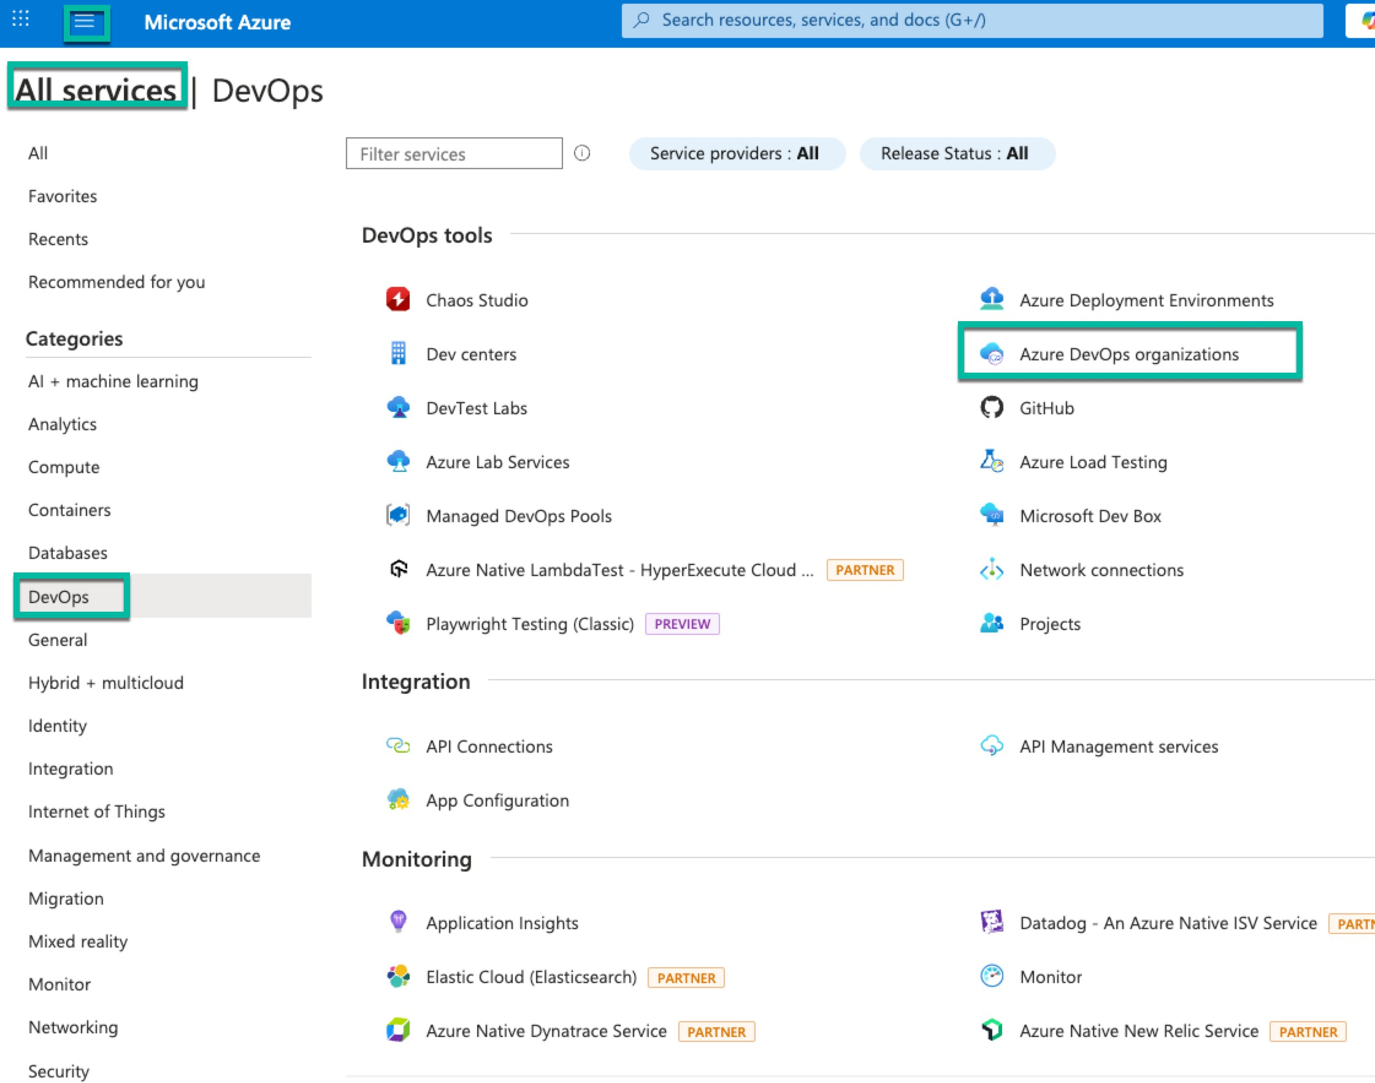

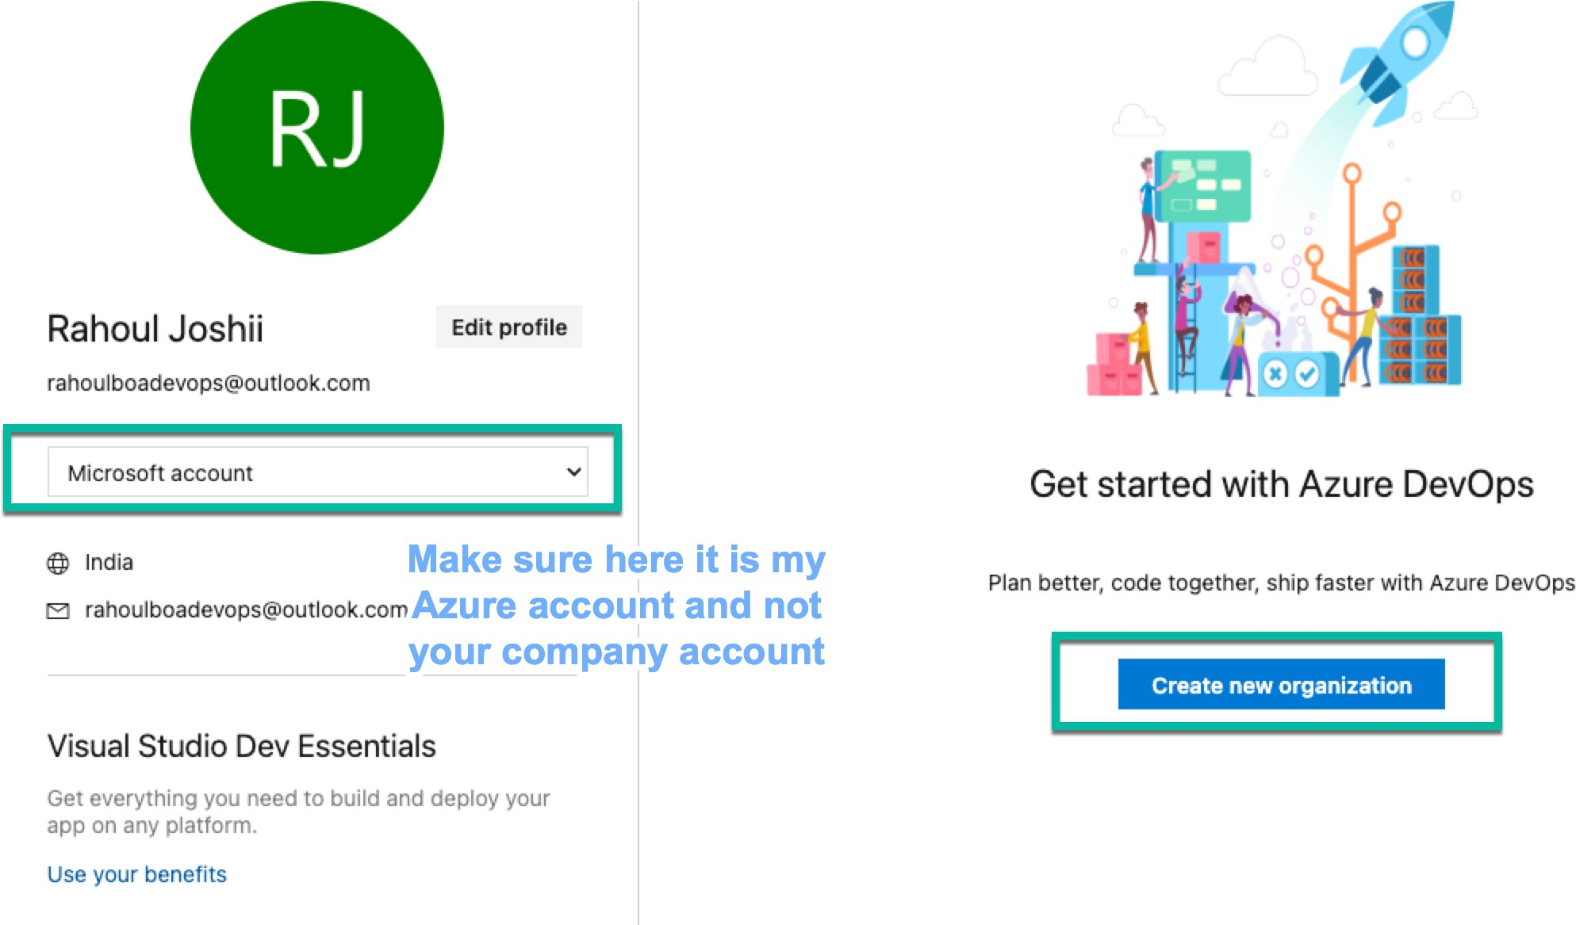

Organization Name has to be unique

- It is the top-level container in Azure DevOps.
- Represents your company, business unit, or team.
- It is linked to an Entra ID or a Microsoft account. Example:
An organization could be named BankCorp-DevOps.
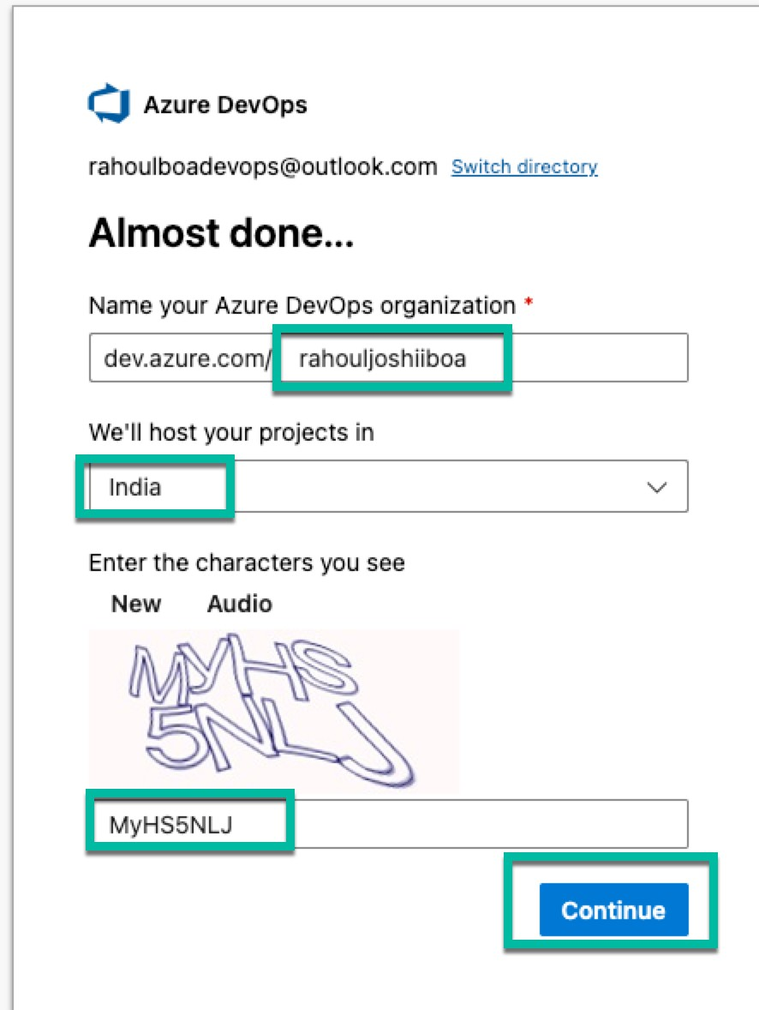

Create a Project, Click on the left side on the organization name
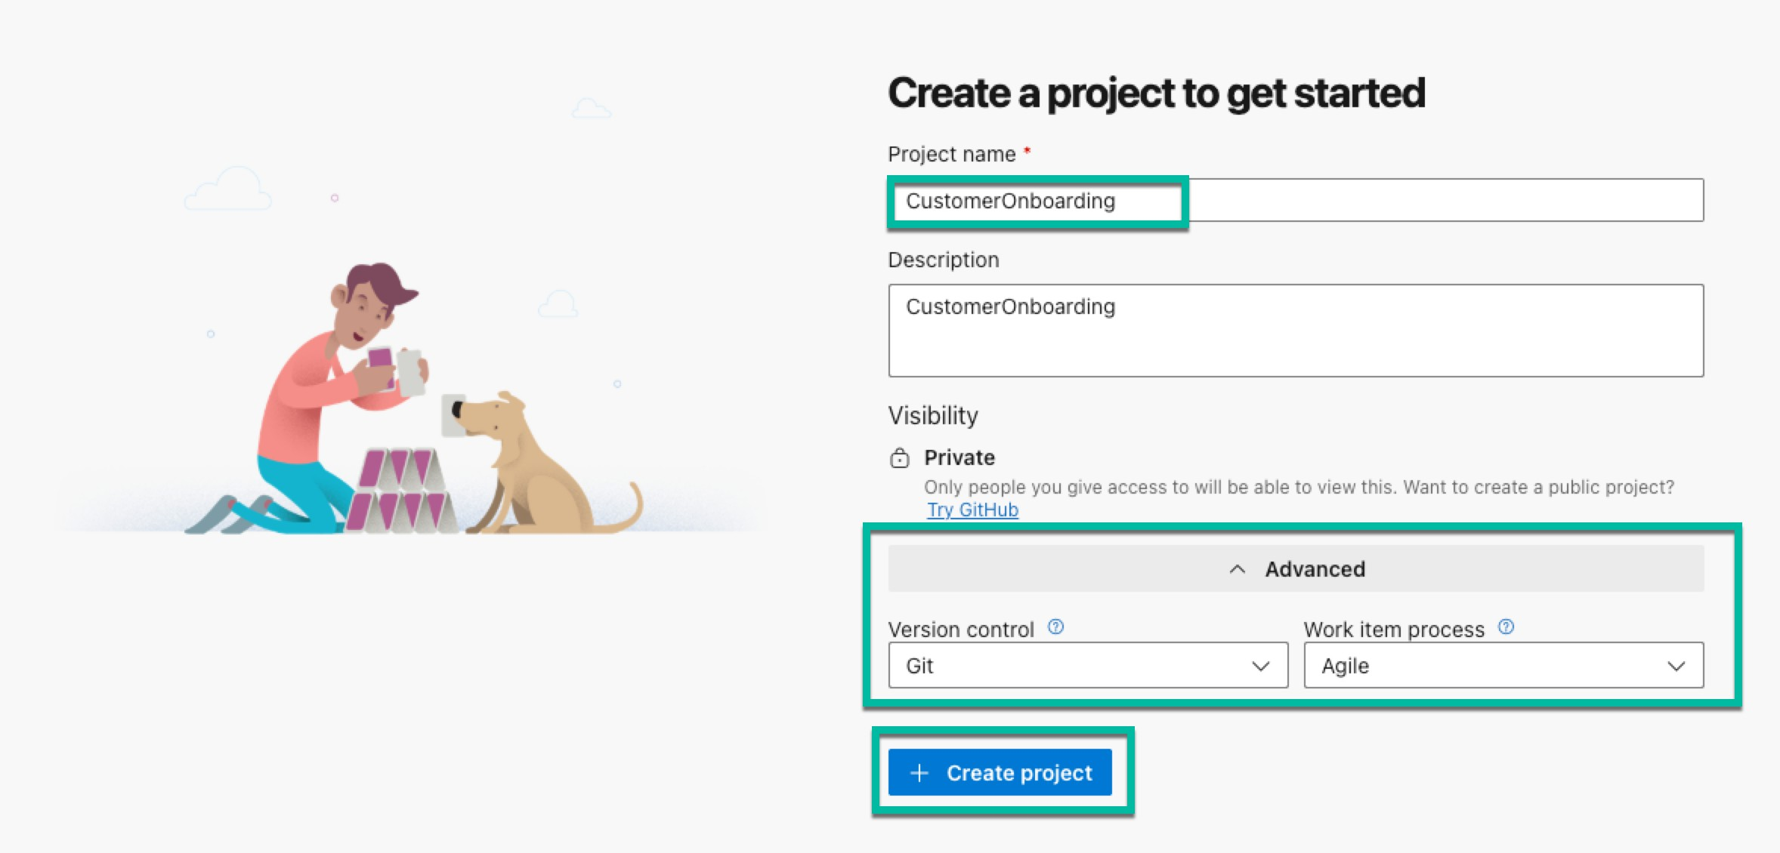

Represents a specific application, service, or a set of related work. Each project contains:

- Repos: Code repositories (Git or TFVC).
- Pipelines: Build and release automation (CI/CD).
- Boards: Work item tracking (Agile, Scrum).
- Artifacts: Package management.
- Test Plans: Test management.

Example:
Project Name: LoanProcessingSystem or CustomerOnboardingWebApp.
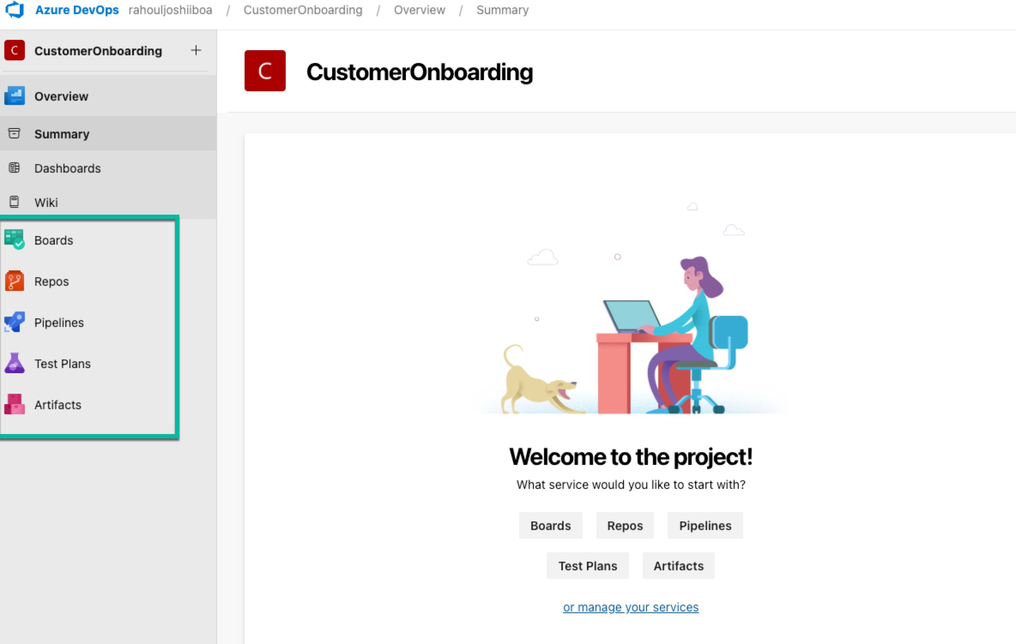

Let us now create a Self-Hosted Agent,

What is an Azure DevOps Agent?

An agent is a compute resource that runs your pipelines (builds, deployments, tests, etc.). It executes the tasks in a pipeline, such as compiling code, running tests, and deploying applications.

Microsoft-hosted Agent

Definition:
Microsoft provides the agent infrastructure as part of the Azure DevOps service. Each time a pipeline runs, a fresh virtual machine (VM) is created from a standard image.

Features:
- Pre-installed tools (SDKs, runtimes, etc.)
- Automatically maintained and updated by Microsoft
- Ephemeral: Clean VM for every run (stateless)
- No setup needed from your side

Pros:
- Easy to use with no infrastructure maintenance
- Always up-to-date tools
- Scales automatically

Cons:
- Slower startup due to VM provisioning
- Limited customization of the environment
- Shared infrastructure may raise compliance concerns
- Limited control over network or security configuration

Self-hosted Agent

Definition:
An agent that you install and manage on your own infrastructure (for example, on-premises VM, Azure VM, or private cloud).

Features:

Full control over the operating system, installed tools, environment, and network

Persistent agent ready for multiple runs
- Can run inside a secured private network
- Suitable for workloads with specific dependencies (custom SDKs or software)

Pros:

Full control of security, network, and compliance
- Suitable for jobs requiring special configurations or on-prem resources
- Faster execution after the first run (no VM provisioning delays)

Cons:
- Maintenance required: You must manage OS updates, security patches, and scalability

- Higher setup effort

Which is Best for a Healthcare / Banking Environment?
Feature | Microsoft-hosted Agent | Self-hosted Agent
Security and Compliance | Limited control | Full control of firewall and private network
Data Privacy | Data goes outside bank network | Data remains within bank network
Specialized Software | Limited customization | Install custom tools, SDKs, and configurations
Maintenance | No maintenance required | Requires managing OS, agent updates
Cost | Pay-per-use included in Azure DevOps | More cost-effective long-term if usage is high
Reliability | Depends on Microsoft’s SLA | Dedicated uptime and security control

Step-by-Step Guide: Setting Up a Self-Hosted Azure DevOps Agent on Windows 11 VM Objective
This guide helps you set up a self-hosted Azure DevOps Agent on a Windows 11 Virtual Machine to run Azure Pipelines without waiting for Microsoft parallelism approval.

Prerequisites
- A valid Azure subscription with an active Windows 11 Virtual Machine (VM).
- Admin access to the Windows 11 VM.
- An Azure DevOps Organization and Project.
- A Personal Access Token (PAT) from Azure DevOps.

Step 1: Connect to Your Windows 11 VM
  - Open Remote Desktop Connection (mstsc) from your local machine.
  - Enter the IP address of your VM.
  - Login with your username and password.

Step 2: Download the Agent Package
- Open a web browser on the VM.
- Go to:
https://dev.azure.com/{your-organization-name}/
- Navigate:
  - Click on Organization Settings (bottom-left corner).
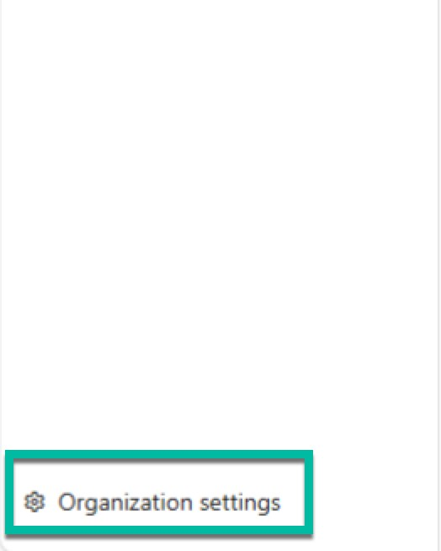
  - Select Pipelines → Agent Pools.
  - Click the desired Agent Pool (e.g., Default).
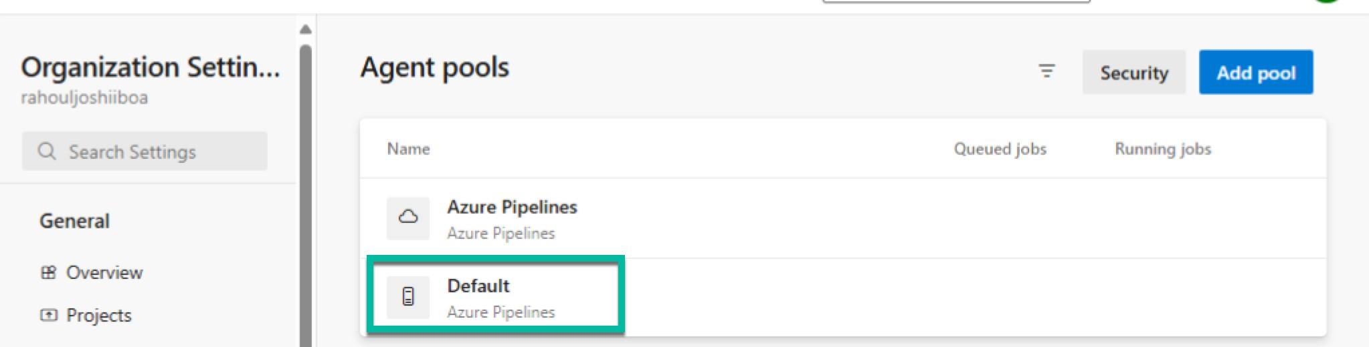

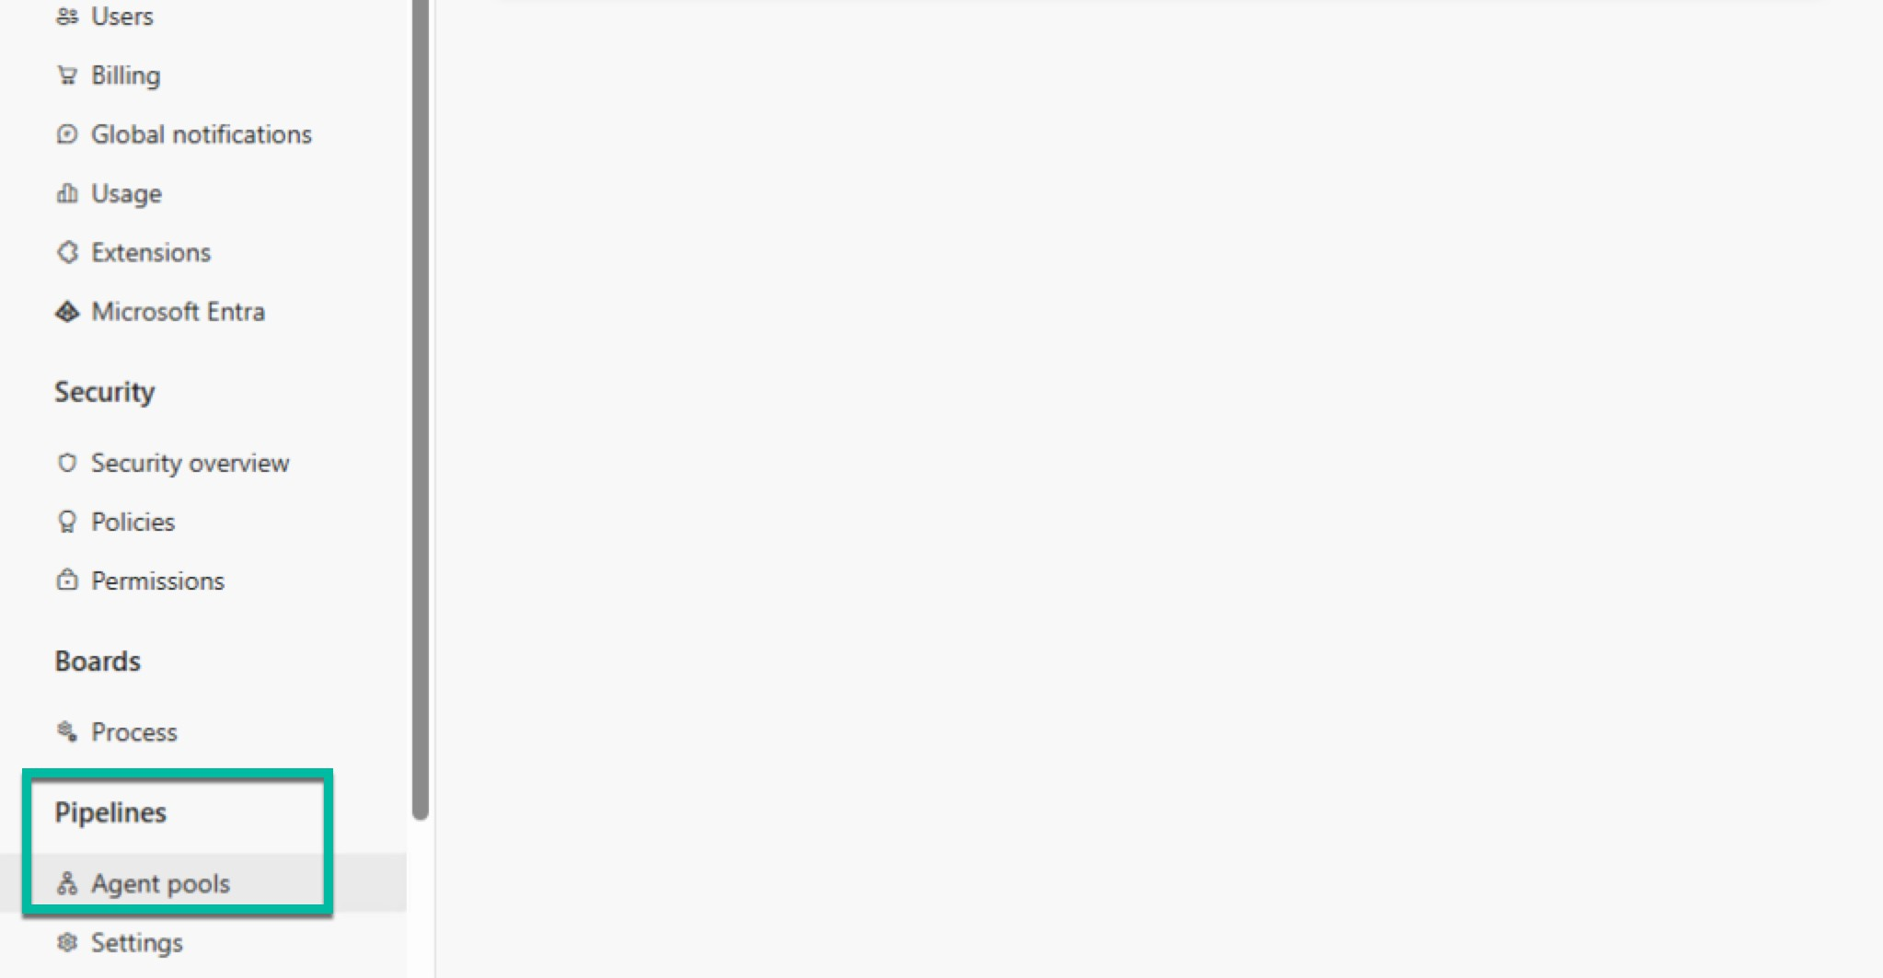
  - Click New Agent.
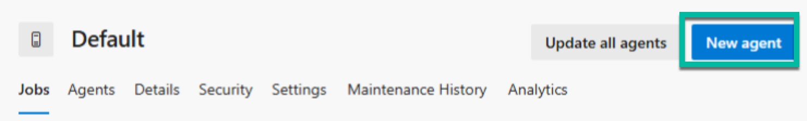

- Choose:
  - OS: Windows
  - Architecture: x64
- Download the agent .zip file to a folder on your VM.
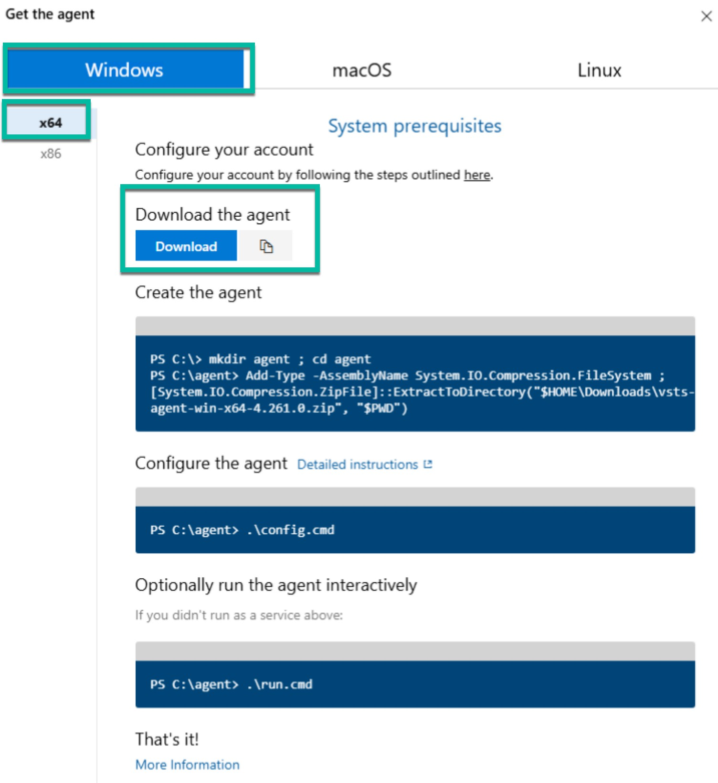

Step 3: Extract the Agent Package
Extract the downloaded zip file to a folder such as: C:\azure-pipelines-agent\

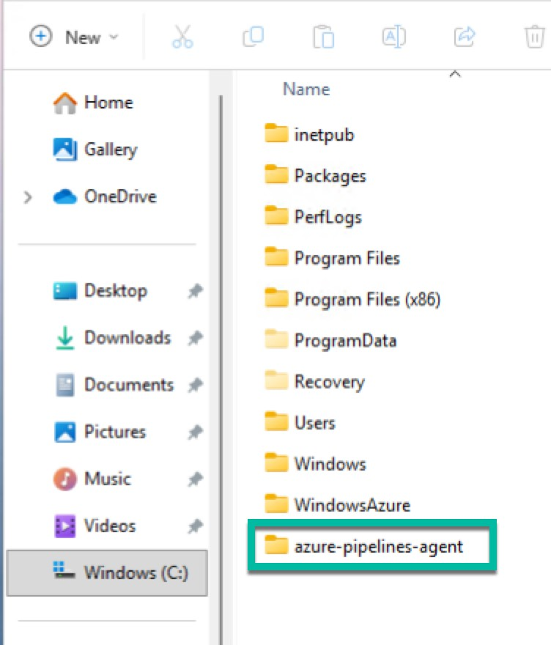

Step 4: Generate a Personal Access Token (PAT)
- In the browser, open:
https://dev.azure.com/{your-organization-name}/_usersSettings/tokens
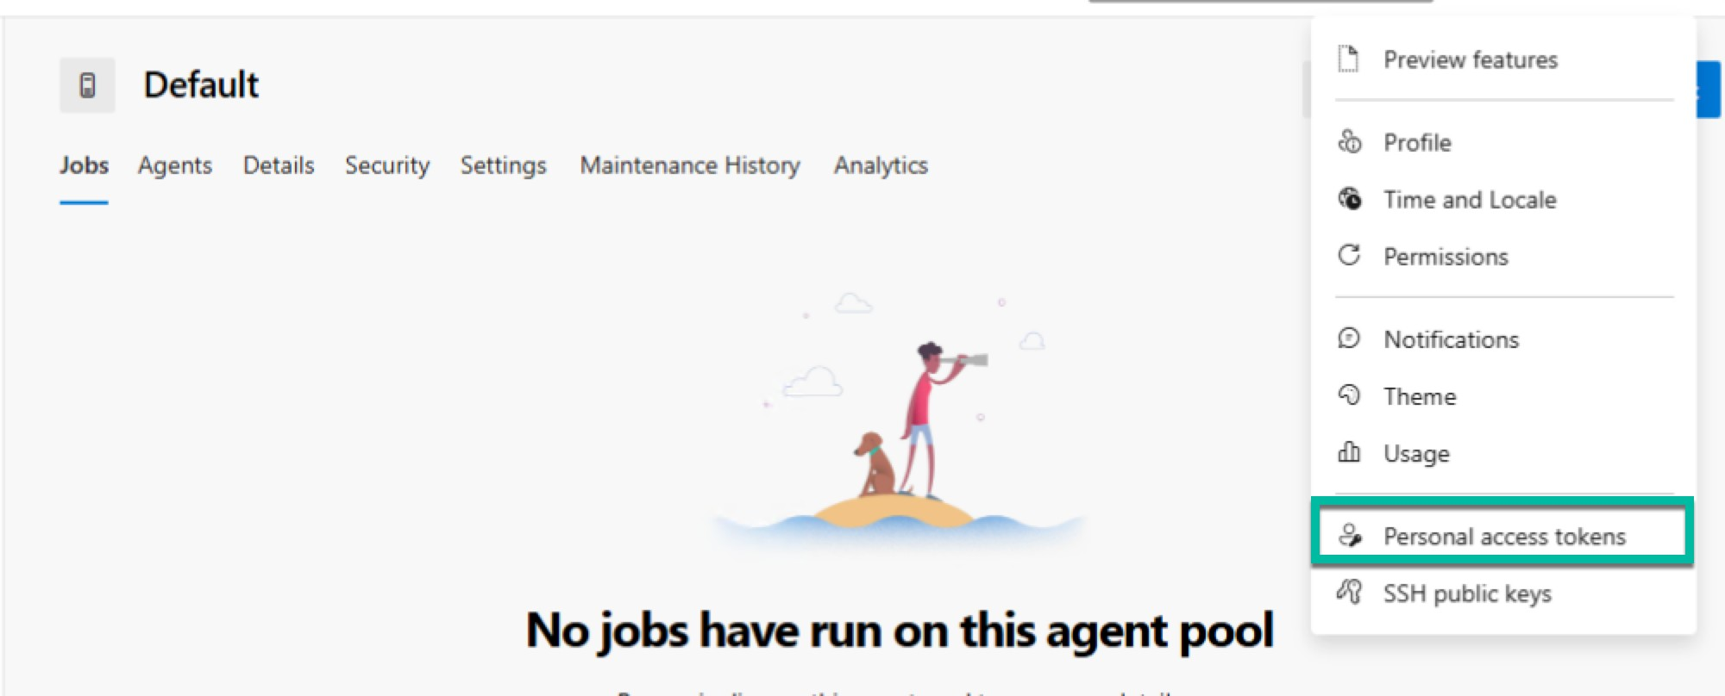
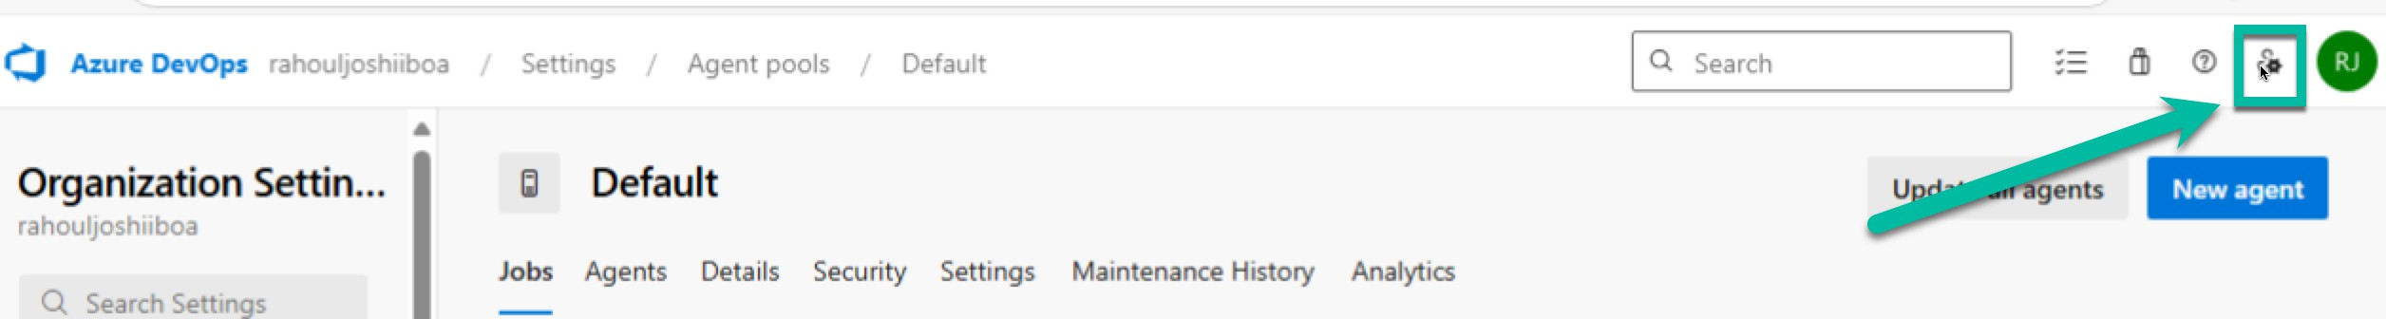

- Click + New Token.
- Set:
  - Name: SelfHostedAgentPAT
  - Expiration: Choose desired expiry (e.g., 90 days).
  - Scopes: Select Agent Pools (read G manage).
- Click Create and Copy the PAT (keep it safe).
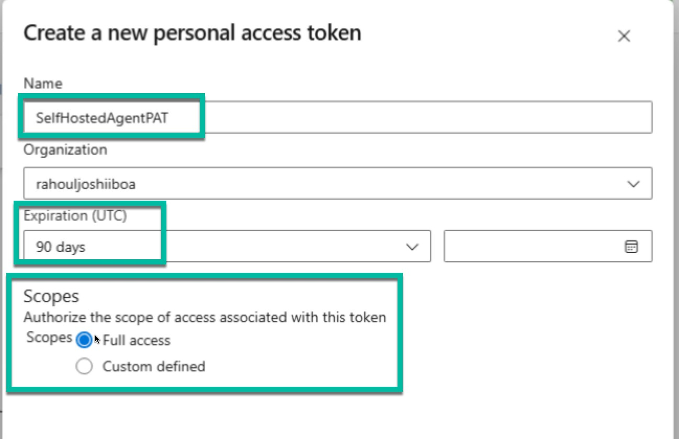

Step 5: Configure the Agent

- Open Command Prompt as Administrator.
Navigate to the agent folder: cd C:\azure-pipelines-agent
- Run configuration: config.cmd

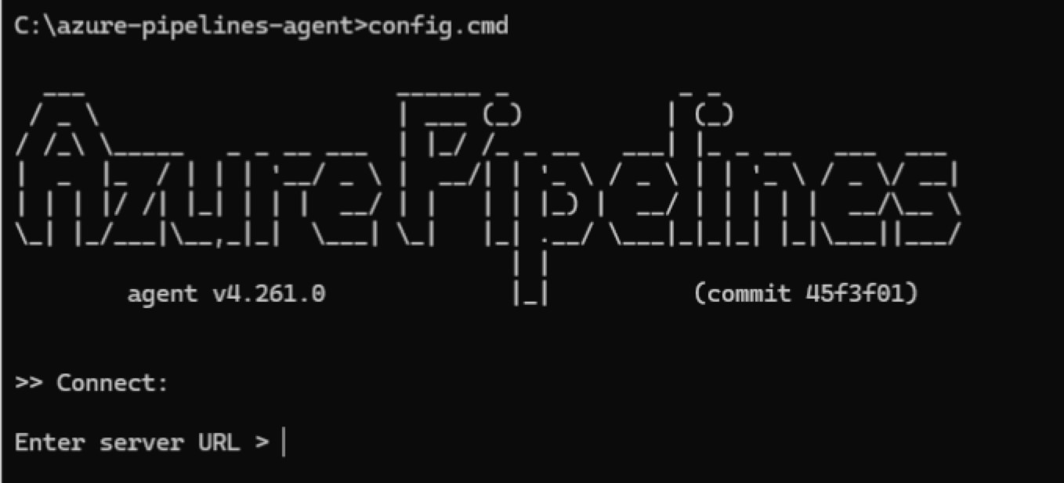
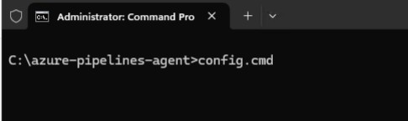

- Follow the prompts:

Server URL:
https://dev.azure.com/{your-organization-name}
  - Authentication type: Select PAT.
  - Paste the PAT generated earlier.
  - Agent Pool name (press enter for default) - Press Enter
  - Agent Name: e.g., win11-agent-2.
  - Work Folder: Leave default (_work).

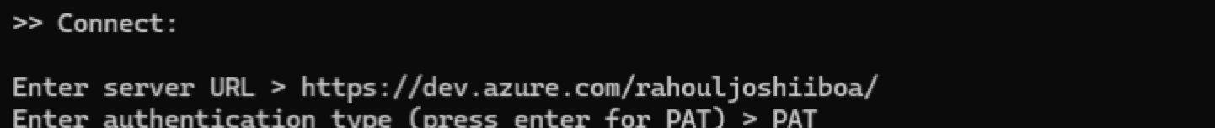
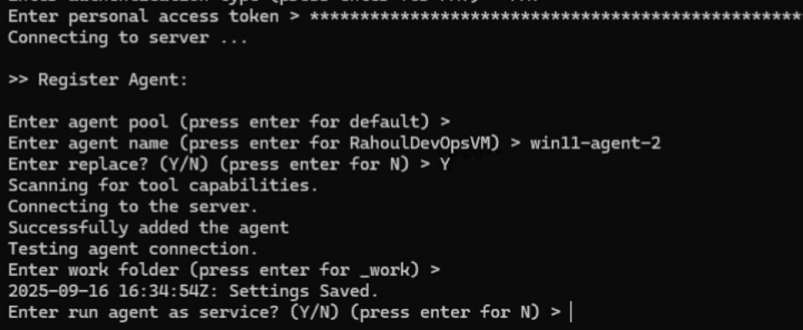

- Wait for confirmation:
Agent successfully configured.
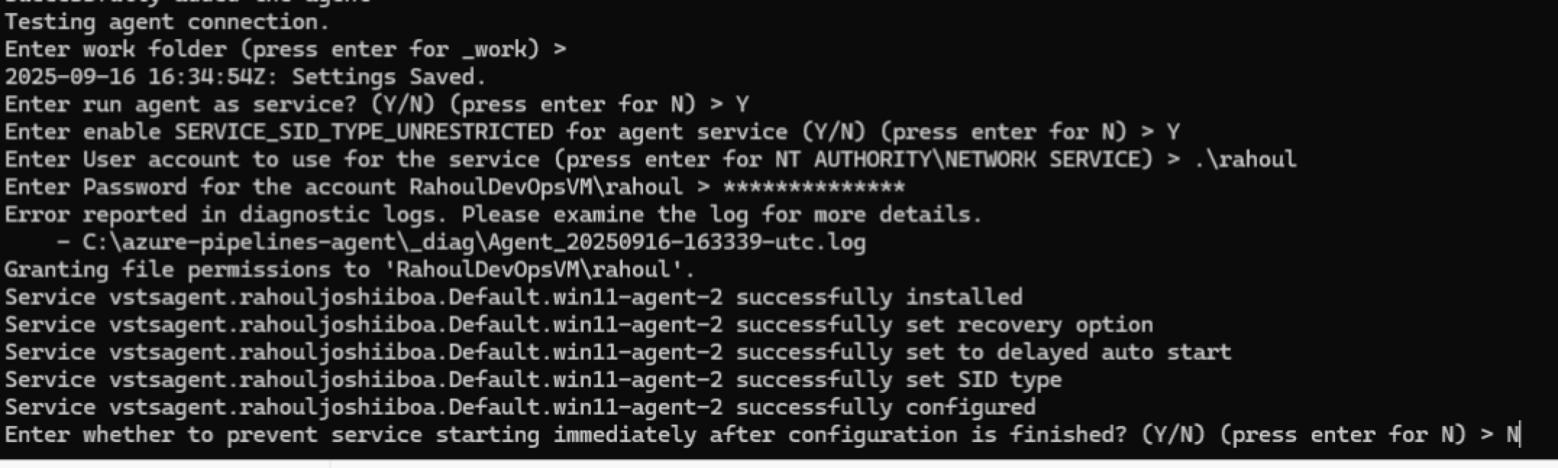
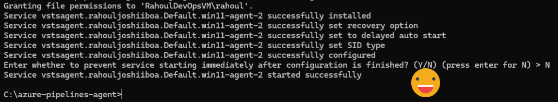

What It Means:
- Windows services can run under special security contexts.
- By default, Windows restricts what service accounts can do.
- Enabling SERVICE_SID_TYPE_UNRESTRICTED:
  - Assigns a unique service security identifier (SID) to the agent service.
  - This allows the agent service to access resources securely and more flexibly (such as network shares or local files).
  - It reduces security risks compared to using broad accounts like NETWORK SERVICE.

Step 6: Verify Agent in Azure DevOps
- Go to:
https://dev.azure.com/{your-organization-name}/_settings/agentpools
- Open the Agent Pool you selected.
- Ensure the newly configured agent shows as Online.
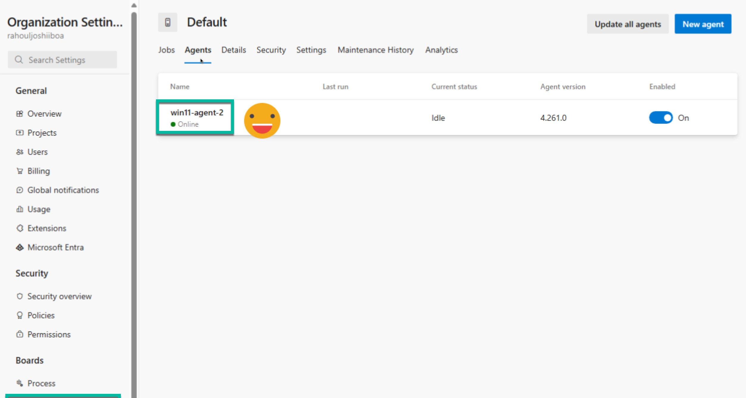

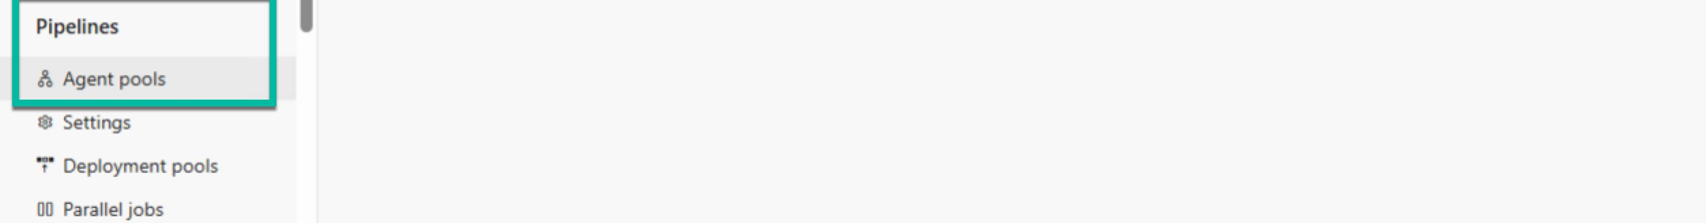

Create a Project

On your Windows 11 VM:

# Create a clean root folder
mkdir C:\BankingAppDemo
cd C:\BankingAppDemo

# Create a new ASP.NET Core MVC project dotnet new mvc -n BankingApp
# Create a solution file
dotnet new sln -n BankingApp

# Add the project into the solution
dotnet sln BankingApp.sln add BankingAppDem\BankingApp.csproj

Now your structure looks like this:

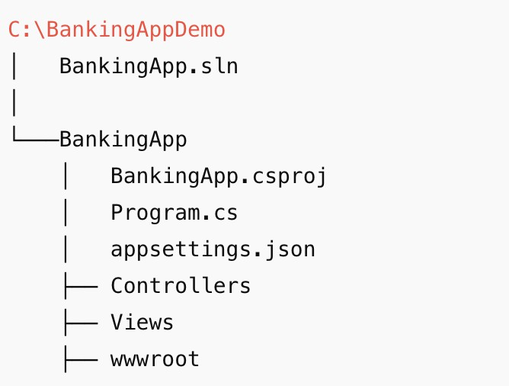

Add Application Insights SDK
From inside the project folder:

cd C:\BankingAppDemo\BankingApp
dotnet add package Microsoft.ApplicationInsights.AspNetCore --version 2.22.0
dotnet restore

Modify Code Program.cs

var builder = WebApplication.CreateBuilder(args);

// Add services
builder.Services.AddControllersWithViews();

// Register Application Insights
builder.Services.AddApplicationInsightsTelemetry();

var app = builder.Build();

// Middleware
if (!app.Environment.IsDevelopment())
{
app.UseExceptionHandler("/Home/Error");
app.UseHsts();
}

app.UseHttpsRedirection();
app.UseStaticFiles();
app.UseRouting();
app.UseAuthorization();

app.MapControllerRoute(
name: "default",
pattern: "{controller=Home}/{action=Index}/{id?}");

app.Run();

Controllers/TransferController.cs

This ASP.NET Core MVC controller handles a fund transfer operation and uses Application Insights to track user activity.

When a transfer is attempted, it logs a FundsTransferAttempt event with account and amount details.

If the amount exceeds ₹10,000, it records a FundsTransferFailed event and displays an error message.

Otherwise, it logs a FundsTransferSuccess event and shows a successful transfer confirmation, enabling monitoring and analysis of transaction behavior in Azure Application Insights.

using Microsoft.AspNetCore.Mvc;
using Microsoft.ApplicationInsights;

namespace BankingApp.Controllers
{
public class TransferController : Controller
{
private readonly TelemetryClient _telemetryClient;

public TransferController(TelemetryClient telemetryClient)
{
_telemetryClient = telemetryClient;
}

[HttpGet]
public IActionResult Index()
{
return View();
}

[HttpPost]
public IActionResult Index(decimal amount, string fromAccount, string toAccount)
{
_telemetryClient.TrackEvent("FundsTransferAttempt", new Dictionary<string, string>
{
{ "FromAccount", fromAccount },
{ "ToAccount", toAccount },
{ "Amount", amount.ToString() }
});

if (amount > 10000)
{
_telemetryClient.TrackEvent("FundsTransferFailed", new Dictionary<string, string>
{
{ "Reason", "Amount exceeds limit" }
});
ViewBag.Message = "❌ Transfer failed: Amount exceeds limit of 10,000.";
return View();
}

_telemetryClient.TrackEvent("FundsTransferSuccess", new Dictionary<string, string>
{
{ "FromAccount", fromAccount },
{ "ToAccount", toAccount },
{ "Amount", amount.ToString() }
});

ViewBag.Message = $"✅ Successfully transferred {amount} from {fromAccount} to {toAccount}.";
return View();
}
}
}

Views/Transfer/Index.cshtml (Here you need to create a folder Transfer)

@{
ViewData["Title"] = "Funds Transfer";
}

<h2>Funds Transfer</h2>

<form method="post" asp-controller="Transfer" asp-action="Index">
<div>
<label>From Account:</label>
<input type="text" name="fromAccount" required />
</div>
<div>
<label>To Account:</label>
<input type="text" name="toAccount" required />
</div>
<div>
<label>Amount:</label>
<input type="number" name="amount" required />
</div>
<button type="submit">Transfer</button>
</form>

@if (ViewBag.Message != null)
{
<p style="color:red">@ViewBag.Message</p>
}

Update Navigation in Views/Shared/_Layout.cshtml
Add link:

<li class="nav-item">
<a class="nav-link text-dark" asp-controller="Transfer" asp-action="Index">Funds Transfer</a>
</li>

Local Test
cd C:\BankingAppDemo
dotnet run --project BankingApp\BankingApp.csproj

  - Navigate to https://localhost:<port>/transfer
  - Test amounts ≤ 10000 (success) and > 10000 (failure).

Push to Azure DevOps Repo

cd C:\BankingAppDemo

git init

git add .

git config --global user.email "rahoul333@outlook.com"

git config --global user.name "Rahoul Joshii"

git commit -m "Initial commit: BankingApp with telemetry"

git branch -M master

git remote add origin https://dev.azure.com/<org>/<project>/_git/BankingApp

git push -u origin master

Replace:
- <org> → Your Azure DevOps organization name
- <project> → Your Azure DevOps project name

Check Azure DevOps → Repos: you must see both BankingApp.sln and the BankingApp/ folder.

Azure Portal Setup
Create Resource Group (BankingDemoRG). Ensure Resource Group Name is unique
Create App Service Plan (BankingAppPlan, B1 Basic, Windows). Ensure WebApp Plan Name is unique
Create Web App (mybankingapp1234, runtime .NET 8, Windows, linked to plan). Ensure WebApp Name is unique, Copy it

Enable Application Insights during creation.

Service Connection in Azure DevOps
Go to Project Settings → Service connections → New → Azure Resource Manager → Service principal (automatic).
Select your subscription.
Name it: AzureServiceConnection. (Ensure the name is unique)
Check Grant access permission to all pipelines.
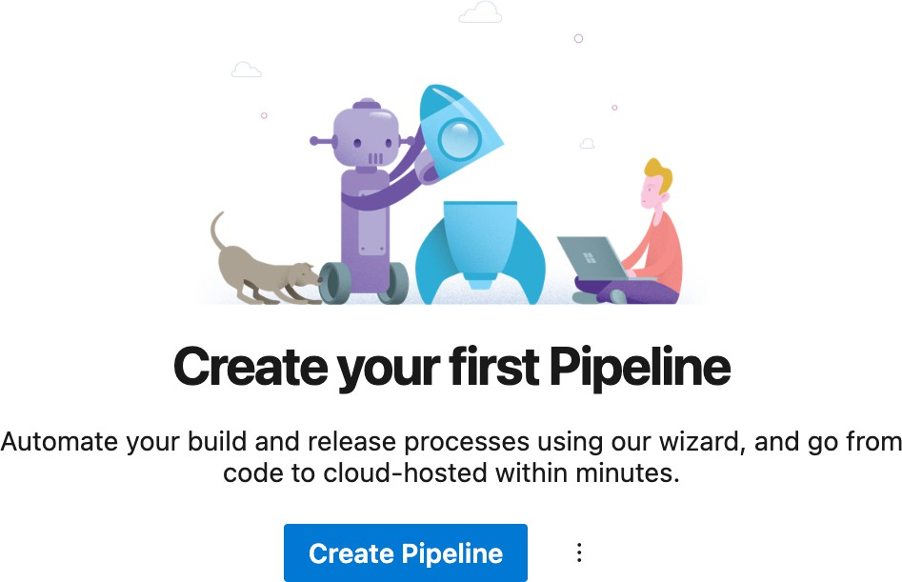

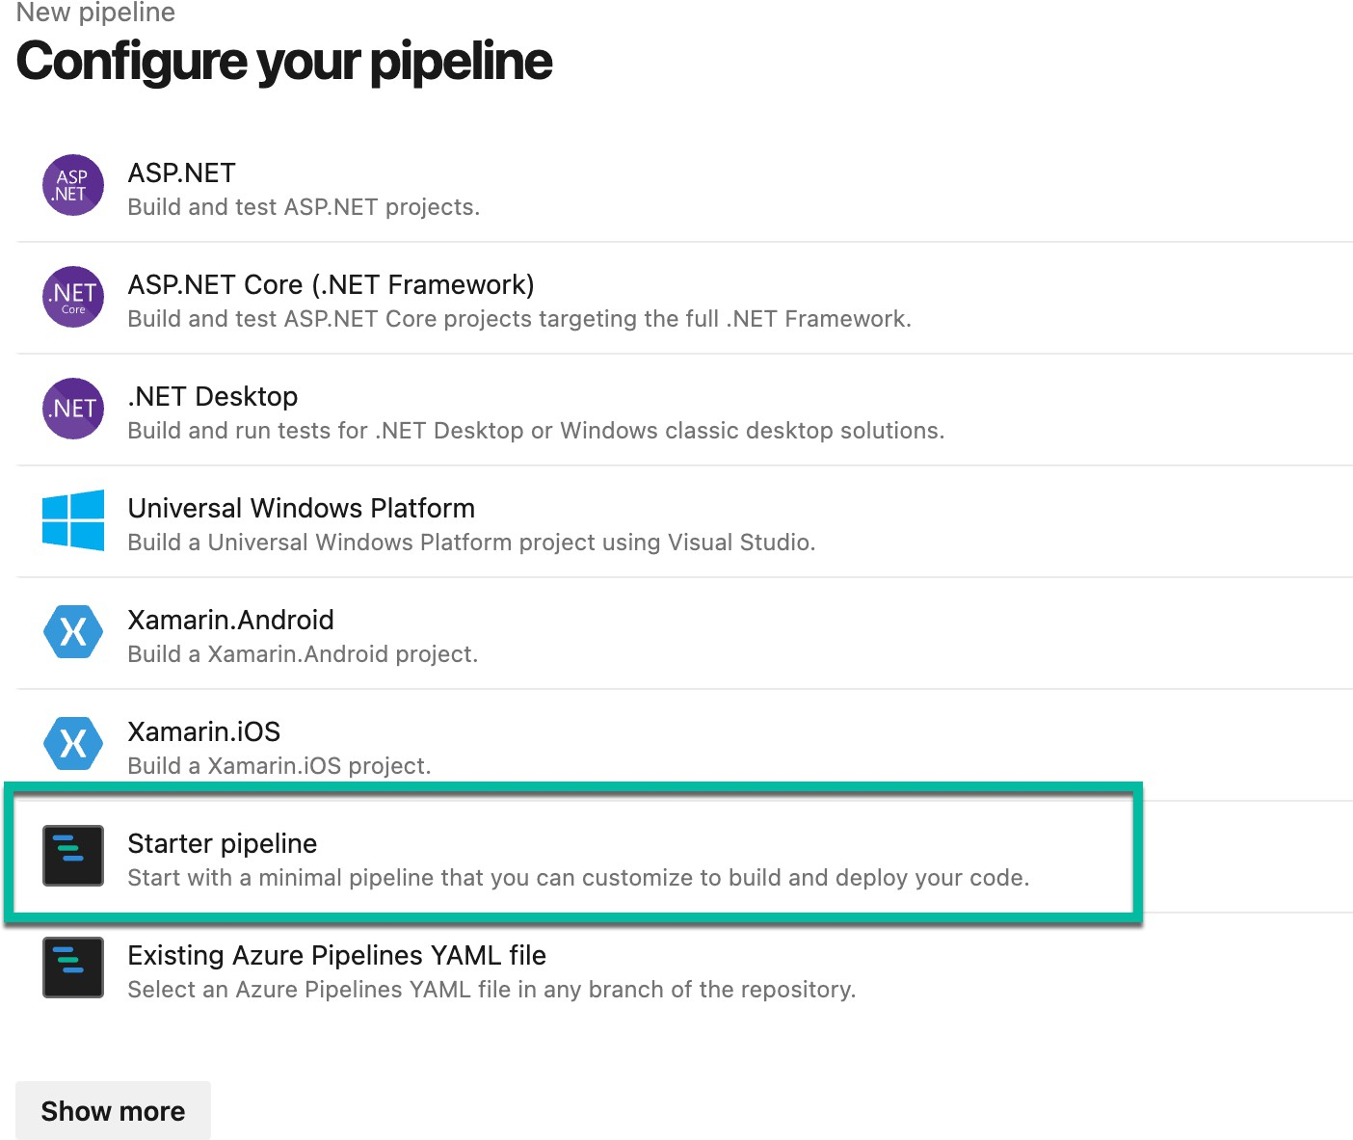
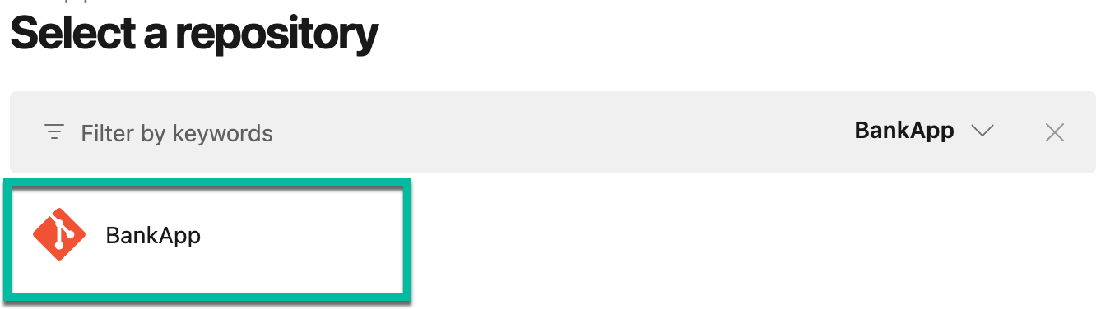
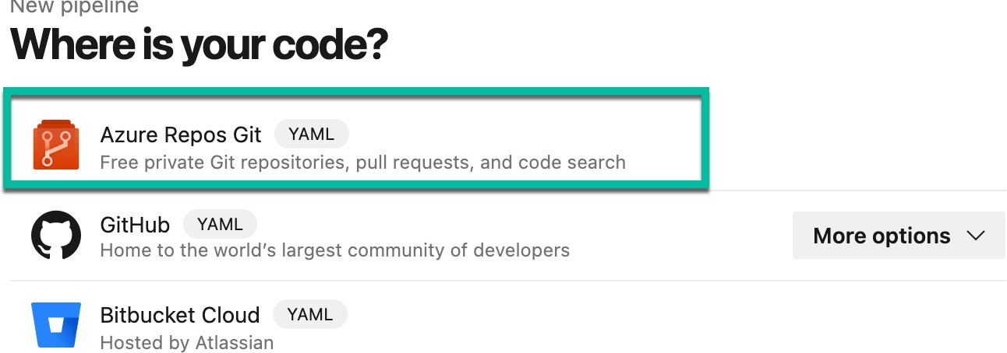

azure-pipelines.yml (change the two things in the code below)

trigger:
branches:
include:
- master

pool:
name: Default

variables:
buildConfiguration: 'Release'
dotnetVersion: '8.x'
webAppName: 'Change This Now'
azureSubscription: 'Change This Now'

steps:

- task: UseDotNet@2
displayName: 'Install .NET SDK'
inputs:
packageType: 'sdk'
version: $(dotnetVersion)

- script: dotnet restore ./BankingApp.sln
displayName: 'Restore packages'

- script: dotnet build ./BankingApp.sln --configuration $(buildConfiguration)
displayName: 'Build solution'

- script: dotnet test ./BankingApp.sln --no-build --configuration $(buildConfiguration)
displayName: 'Run tests'

- script: dotnet publish ./BankingApp.sln -c $(buildConfiguration) -o $(Build.ArtifactStagingDirectory)/publish_output
displayName: 'Publish application'

- task: PublishBuildArtifacts@1
displayName: 'Publish build artifacts'
inputs:
PathtoPublish: '$(Build.ArtifactStagingDirectory)/publish_output'
ArtifactName: 'drop'
publishLocation: 'Container'

- task: AzureWebApp@1
displayName: 'Deploy to Azure Web App'
inputs:
azureSubscription: $(azureSubscription)
appType: 'webApp' # REQUIRED FIX
appName: $(webAppName)
package: '$(Build.ArtifactStagingDirectory)/publish_output'

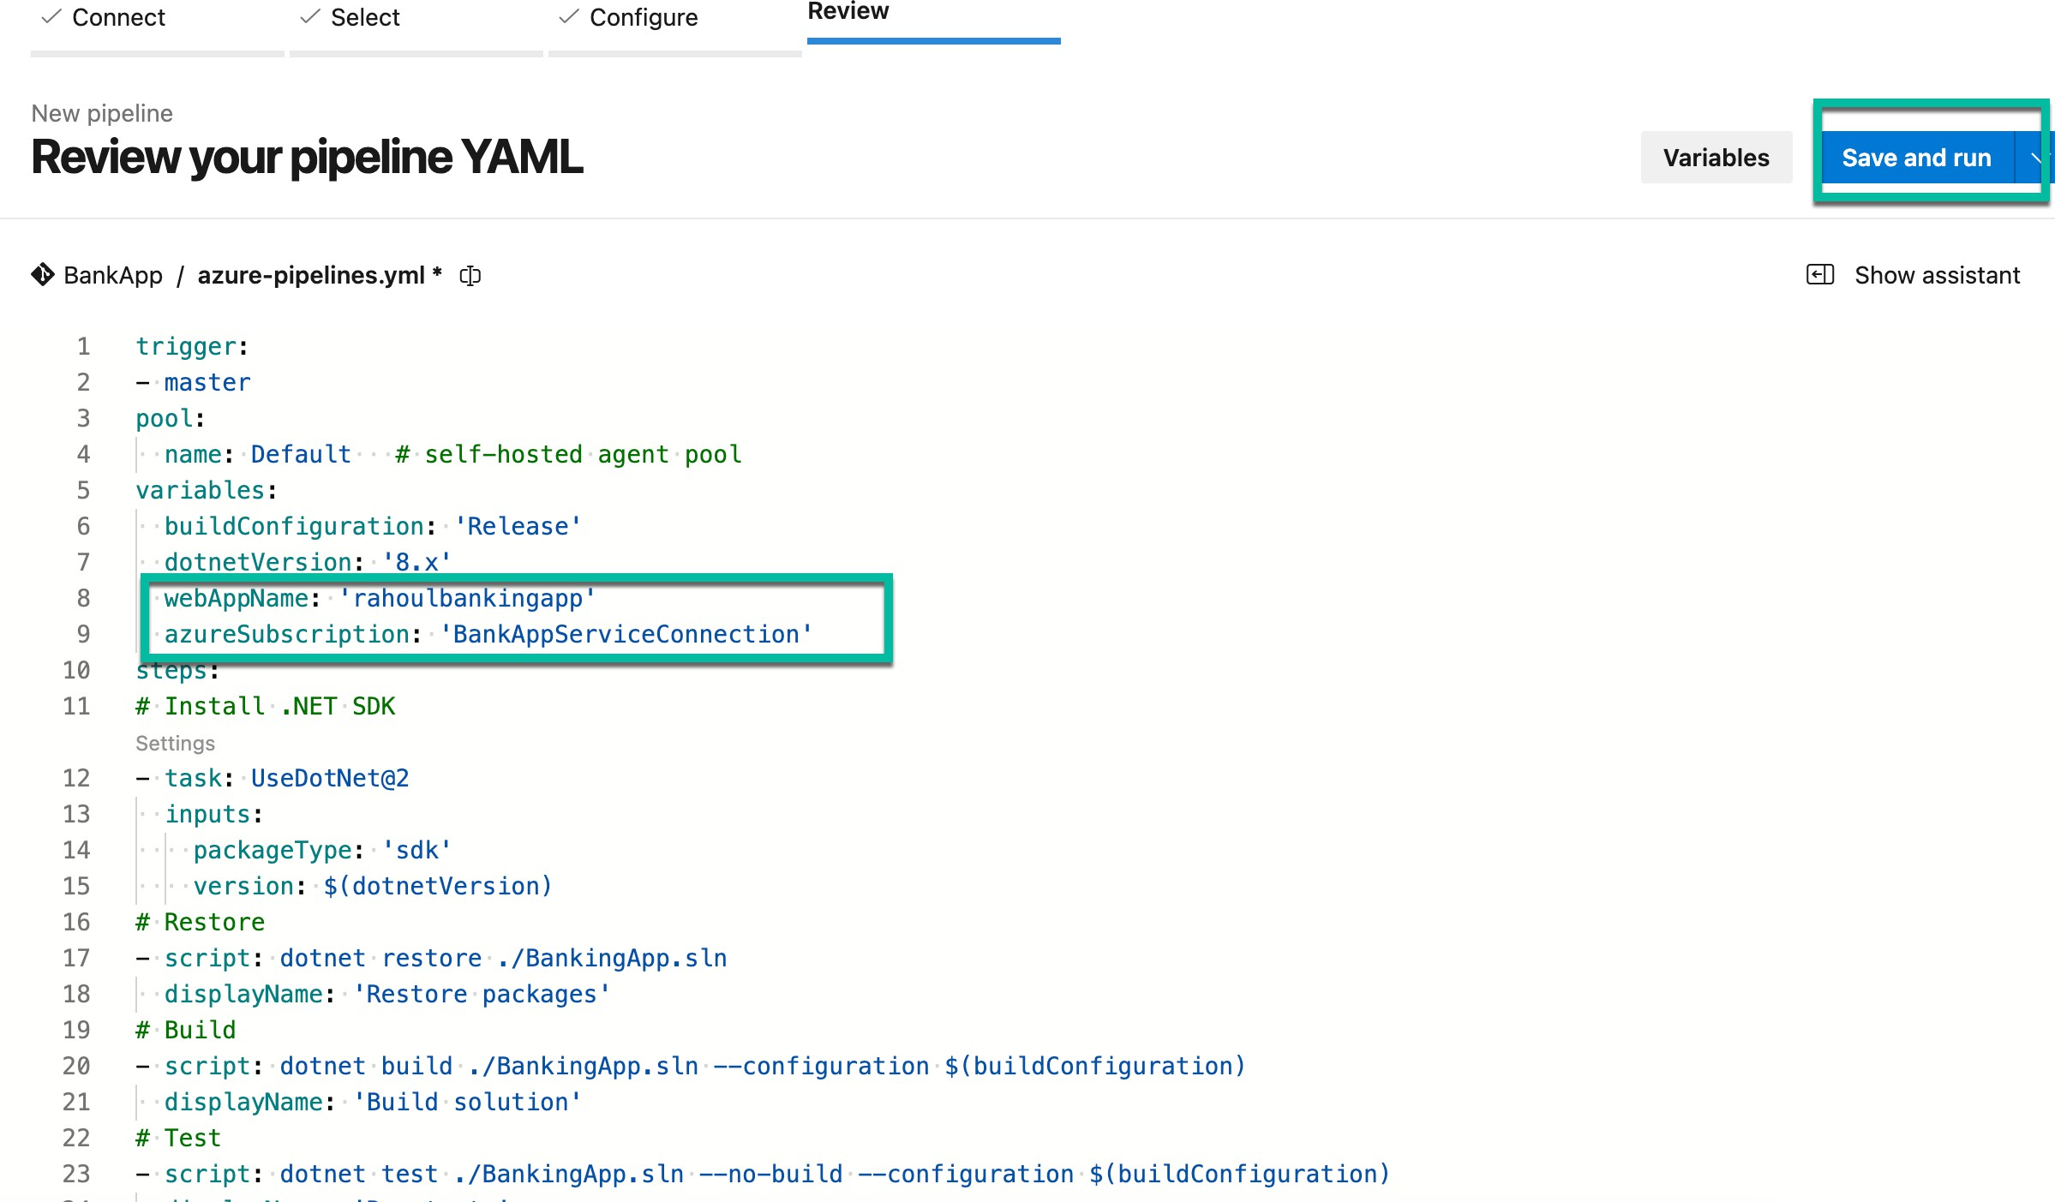

Run Pipeline
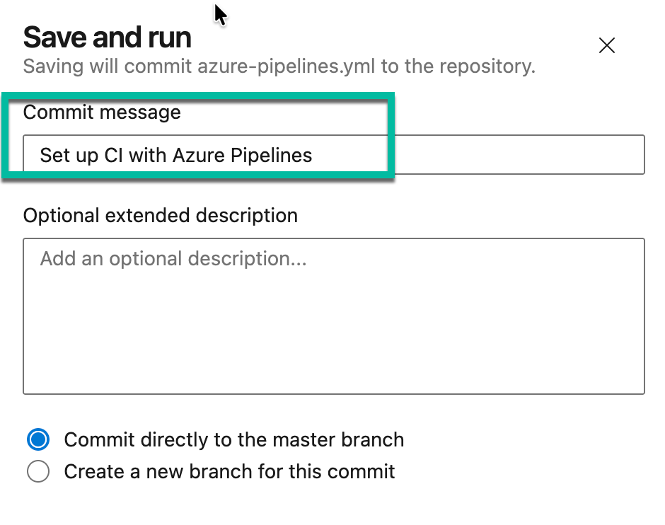

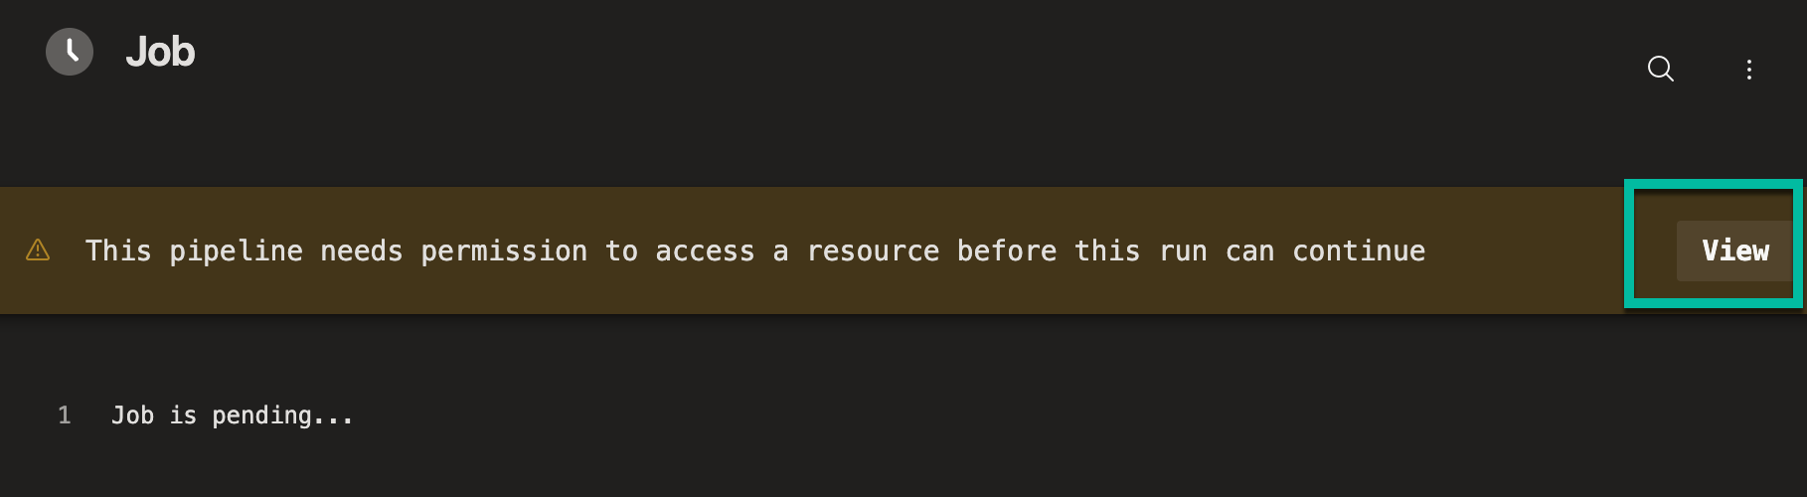

Permit the pipeline to run
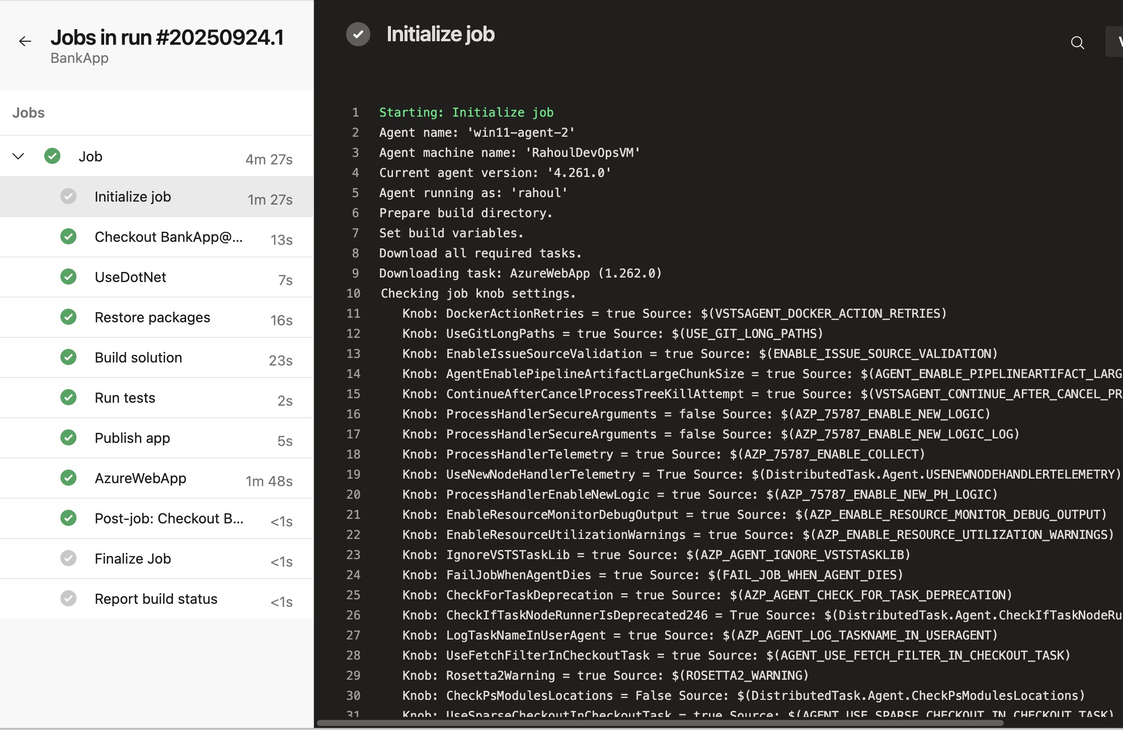

Verify

If successful → app deployed at: https://mybankingapp1234.azurewebsites.net/transfer
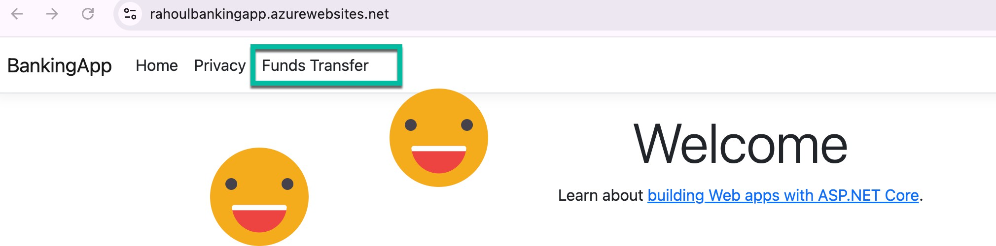

Validate Telemetry
  - Go to Application Insights → Live Metrics (see real-time requests).
  - Use Logs (KǪL) for business events:
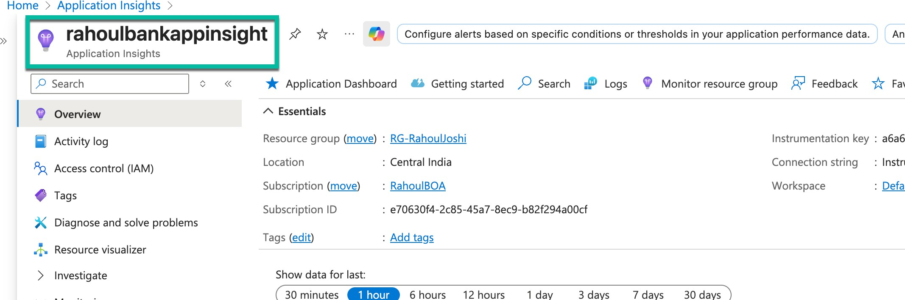

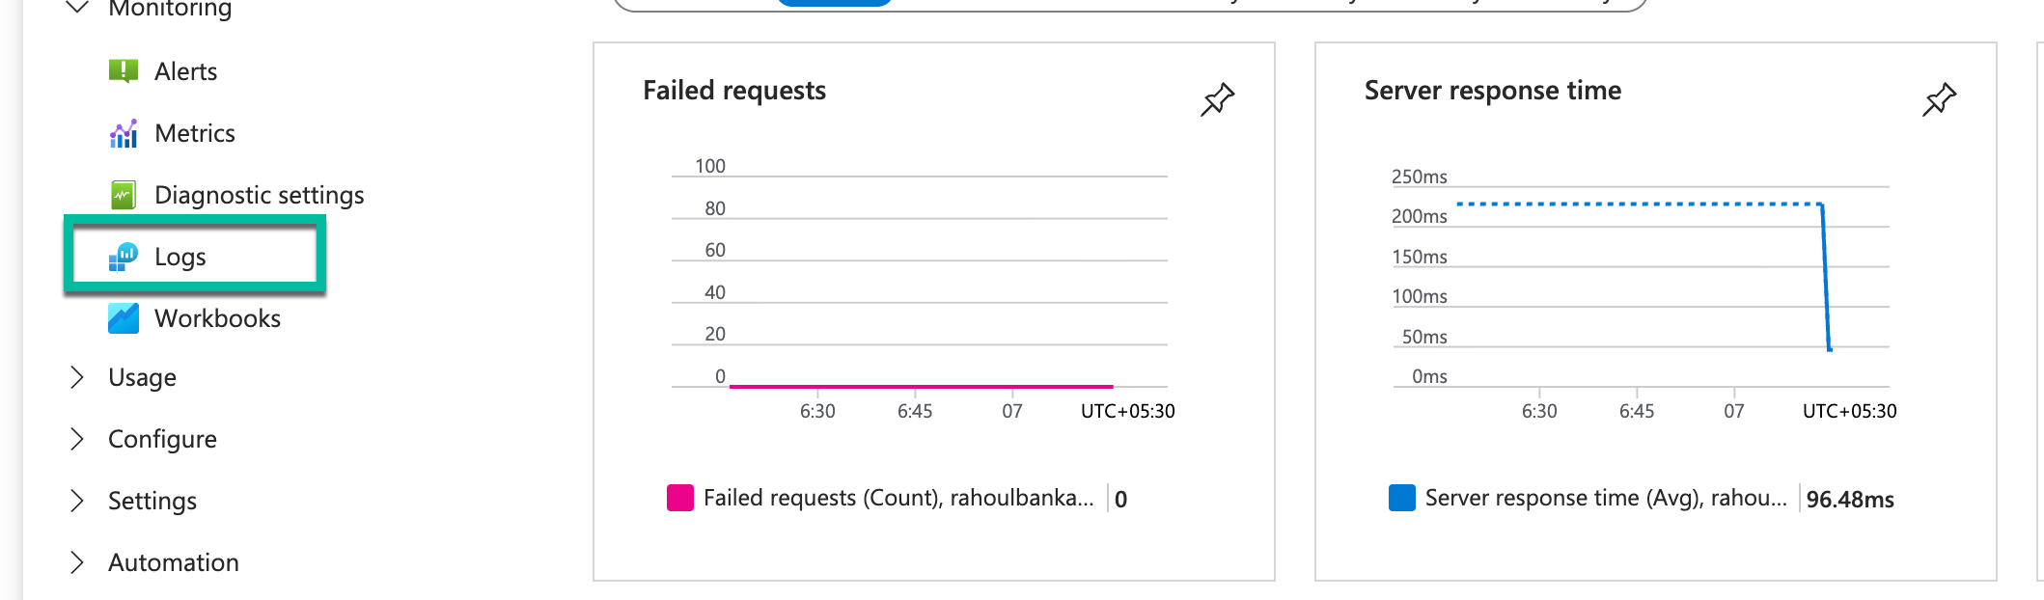

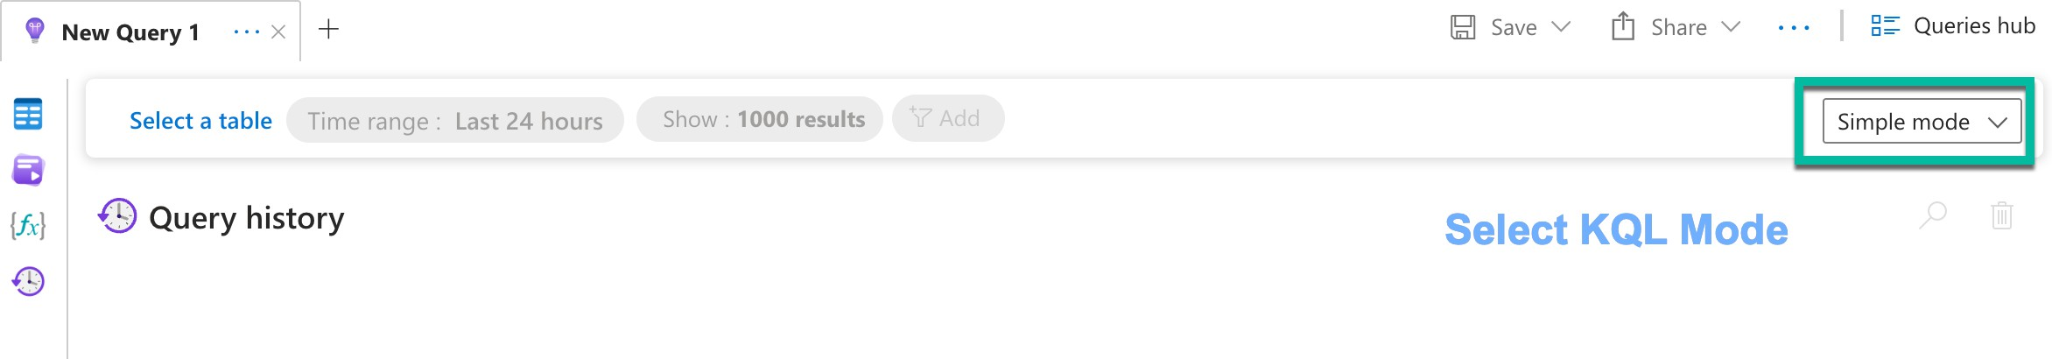

Failed Transfers

customEvents
| where name == "FundsTransferFailed"
| summarize Failures=count() by tostring(customDimensions.FromAccount), bin(timestamp, 5m)

Fraud Detection (>5 failures per account in 10 mins)

customEvents
| where name == "FundsTransferFailed"
| summarize Attempts=count() by tostring(customDimensions.FromAccount), bin(timestamp, 10m)
| where Attempts > 5

//
// 1. All Transfer Attempts (Success + Failures)
// customEvents
| where name in ("FundsTransferAttempt", "FundsTransferSuccess", "FundsTransferFailed")
| summarize Count = count() by name, bin(timestamp, 5m)
| render timechart
//
// 2. Failed Transfers by Reason
// customEvents
| where name == "FundsTransferFailed"
| summarize Failures = count() by tostring(customDimensions.Reason), bin(timestamp, 10m)
| render barchart
//
// 3. Success vs Failure Ratio
// customEvents
| where name in ("FundsTransferSuccess", "FundsTransferFailed")
| summarize Success = countif(name == "FundsTransferSuccess"), Failure = countif(name == "FundsTransferFailed")
| project SuccessRate = todouble(Success) / (Success + Failure) * 100, FailureRate = todouble(Failure) / (Success + Failure) * 100
//
// 4. High-Risk Accounts (Fraud Detection)
// Accounts with more than 3 failed attempts in 10 minutes
// customEvents
| where name == "FundsTransferFailed"
| summarize FailedAttempts = count() by tostring(customDimensions.FromAccount), bin(timestamp, 10m)
| where FailedAttempts > 3
| order by FailedAttempts desc
//
// 5. Transaction Amount Distribution
// customEvents
| where name in ("FundsTransferSuccess", "FundsTransferFailed")
| extend Amount = todouble(customDimensions.Amount)
| summarize AvgAmount = avg(Amount), MaxAmount = max(Amount), MinAmount = min(Amount) by name
//
// 6. Top Transfer Destinations
// customEvents
| where name == "FundsTransferSuccess"
| summarize Transfers = count() by tostring(customDimensions.ToAccount)
| top 5 by Transfers desc
//
// 7. Performance Monitoring (Request Duration)
// requests
| summarize AvgDuration = avg(duration), MaxDuration = max(duration) by bin(timestamp, 5m)
| render timechart
